Report VR&AR Assignment 2 - Lukas FRITZ - 686330

Link to the Github repository: [https://github.com/Vamus26/arvr2](https://github.com/Vamus26/arvr2%20)

As a starting point I used the Ray Wenderlich tutorial from the myCourses section and imported VR samples& SteamVR assets.

In the most familiar acuity test, a Snellen chart is placed at a standard distance: 6 meters. At this distance, the symbols on the line representing "normal" acuity subtend an angle of five minutes of arc, and the thickness of the lines and of the spaces between the lines subtends one minute of arc. This line designated 6/6 (or 20/20), is the smallest line that a person with normal acuity can read at a distance of 6 meters (20 ft).

As my chart is at z= 4.9 my camera has to be at z=-1.1 to get the 6 meter distance.



Omegaw {\displaystyle w} Oms is the optotype height and width as it is squared. d is the distance to the chart (6 meters). Theta is 5 arcminutes as specified by Snellen.  
One arcminute is the sixtieth part of an angle so 5/60 degrees.

For 6m:

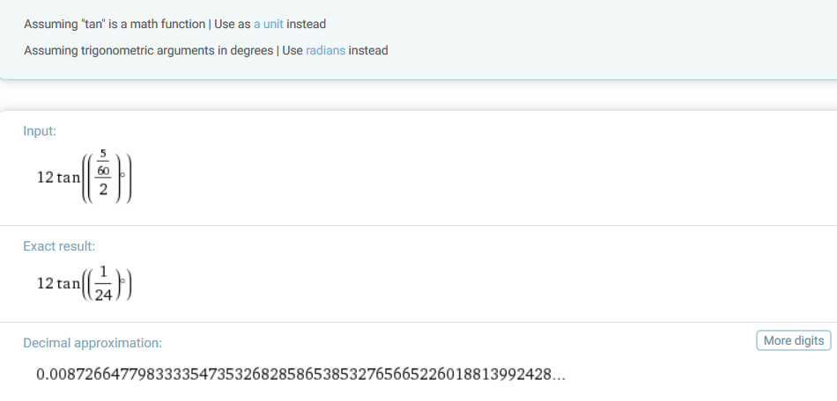

So the top E has to be 87,3mm big to be correctly sized. First I made the mistake to use radians instead of degrees.

I scaled a cube to match 8,7cm and adjusted the size of the graphic that the big E has the fitting size. (a standard cube is 1meter x 1meter x 1meter)

For 3m:

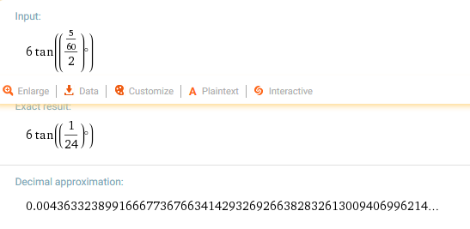

On the floor I have marked the 3m and 6m distance to the charts, and I have scaled both charts accordingly to the calculations on top. You should be able to see the underlined row in a normal eye test at the doctor.

The test showed that a ‘normally’ seeing person sees way less in the virtual world, so would fail the Snellen test and would lose the license to drive without appropriate glasses.

CETD was possible at the edge of 6m. At about 3m distance DCZTFP was still possible. Under that the letters became too pixelated to be readable at all, which is still way worse than reading in reality.

As a bonus I have included a laser pointer on the button press that you could point on the letter you are trying to read. To test the 3m chart you have to move the Camera rig to the fitting position beforehand as I didn’t implement teleportation functionality.

Resources:

<https://en.wikipedia.org/wiki/Snellen_chart#.226.2F6.22.28m.29_or_.2220.2F20.22.28ft.29_vision>

<https://www.raywenderlich.com/149239/htc-vive-tutorial-unity>